|  |  |  |
| --- | --- | --- |
| **FEE STRUCTURE- 2025-2026** | | |
| **CLASS** | **FEE** | **REGISTRATION** |
| PLAY SCHOOL | 2300 | 3000 |
| NURSERY | 2300 | 3000 |
| LKG | 2150 | 3000 |
| UKG | 2200 | 3000 |
| 1 | 2350 | 3000 |
| 2 | 2400 | 3000 |
| 3 | 2500 | 3000 |
| 4 | 2650 | 3000 |
| 5 | 2750 | 3000 |
| 6 | 2900 | 3000 |
| 7 | 3050 | 3000 |
| 8 | 3150 | 3000 |
| 9 | 3300 | 3000 |
| 10 | 3450 |  |
| 11 |  | 3500 |
| SCIENCE | 3850 |  |
| HUMANITIES | 3700 |  |
| COMMERCE | 3700 |  |
| 12 |  | 4000 |
| SCIENCE | 4250 |  |
| HUMANITIES | 4150 |  |
| COMMERCE | 4150 |  |

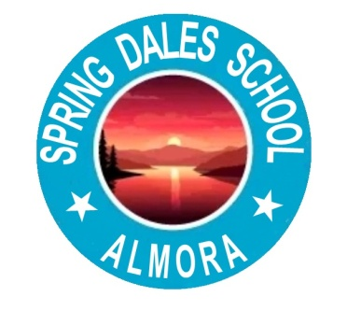

**SPRING DALES SCHOOL ALMORA**

Link Road, Near Text Stand, Almora Pin-263601

AFFLIATED WITH C.B.S.E. DELHI CODE NO- 3530151 SCHOOL NO-81386